**C:\Users\teschowv\AppData\Local\Microsoft\Windows\Temporary Internet Files\Content.IE5\231X8U5C\MC900434389[1].wmfC:\Users\teschowv\AppData\Local\Microsoft\Windows\Temporary Internet Files\Content.IE5\JUV9HYG7\MC900434667[1].wmf Finished your Math?**

**Think about this…**

**Sentences to Finish in Your Mind:**

* I decided to use a (graph, table, T-chart, picture, model, sentence) to solve the problem because…
* The math words that help someone understand what I did are…
* I could make this clearer by…
* The most important thing I learned in math today is…
* This new math idea is like…
* We do this at home when…
* The hardest part of this unit on _________ so far has been…
* I need help with ______ , because…
* Mathematics is like ______ because…
* I solved the problem by…
* Draw a picture or comic to show the steps you used to solve the problem.
* Prove that there is only one possible answer to this problem.

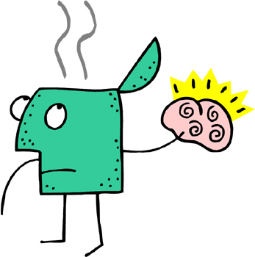

**Questions to Stretch Your Thinking:**

How did you solve the problem?

What did you do?

What were you thinking when you selected strategies to solve the problem?

What questions did you have as you were thinking or working on the solution?

How else could you have solved the problem?

What was the most challenging part of the task? Why?

What math words did you use or learn?

How would you explain _________ (concept) to a student in Grade 1?

What did you learn today?

Think about the math you were doing today. How do you use this sort of math at home? At school? In other places?